Client-Side Technologies – Lab No. 1 – HTML

Write both the HTML5 and XHTML versions for at least one of the following pages. (The XHTML header is included in the lab file on Moodle)

Note: The HTML5 code should use the HTML5 semantic elements: <header>, <main> and <footer>.

The XHTML code should use appropriate <div> elements to divide the page into Header, Main and Footer sections.

Validate all code using the validator at <https://validator.w3.org>

Part 1: Write the HTML to create the following web-page:

(You’ll find the images on Moodle under Lab1)

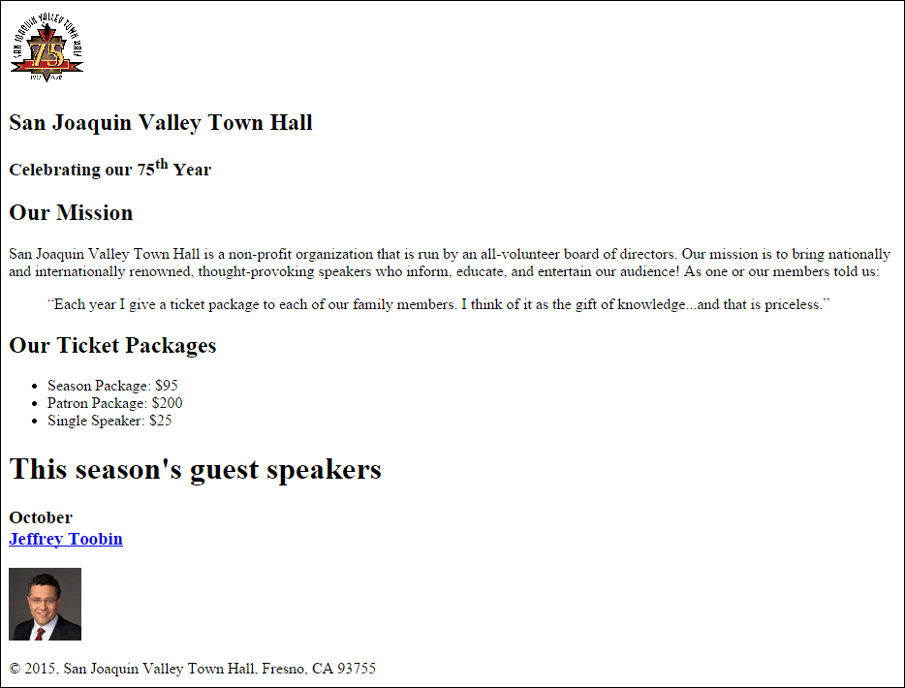

Part 2: Write the HTML to create the following web-page:

(You’ll find the images on Moodle under Lab1)



Part 3: Write the HTML to create the following web-page:

(You’ll find the images on Moodle under Lab1)

